TABLE OF CONTENTS

1. Use
2. Main elements
3. Main symbol
3.1 Concentration (C)
3.2 Stage of development (S)
3.3 Form of ice (F)
4. Symbols for dynamic processes
5. Symbols for water openings
6. Symbols for topographical features
7. Symbol for ice thickness
8. Symbol for stage of melting
9. Symbol for surface features
10. Symbols for ice
10.1 Ice of land origin
10.2 Specification of icebergs
10.3 Ice of sea origin
11. Symbols for limits
12. Symbol for strips and patches
13 Supplementary procedures for indicating total concentration
14. Symbols for the hatching of total concentration of sea ice
15. Additional symbols for regional use
ANNEX I — Tables of ice symbols
ANNEX II - Examples of the use of the ‘oval’ symbol

INTERNATIONAL SYSTEM OF SEA-ICE SYMBOLS

1. USE
The international system of sea-ice symbols is intended for use on synoptic and prognostic ice charts which are issued by national ice centres, either by radio-facsimile or by mail, primarily to serve operational marine activities. Charts transmitted to users by ice-observing units should also follow the international system. Additional symbols determined on the basis of regional or national requirements may be added, provided that they do not overlap or contradict the international system.

2. MAIN ELEMENTS
The system encompasses ice elements and features which can be grouped under the following headings:

(a) Concentration (C);
(b) Stage of development (S);
(c) Form of ice (F);
(d) Dynamic processes;
(e) Water openings;
(f) Topography;
(g) Ice thickness;
(h) Stage of melting;
(i) Surface features;
(j) Ice of land origin;
(k) Limits;
(l) Strips and patches.

3. MAIN SYMBOL
The basic data concerning concentration, stage of development (with amounts of up to three age classes) and form of ice are contained in a simple oval form (the egg; see Annex II for examples).

3.1 Concentration (C)
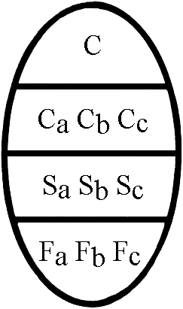
C - Total concentration of ice in the area, reported in tenths (see table in Annex I).
NOTE: Ranges of concentration may be reported; see example in Annex II.
C_{a}C_{b}C_{c} - Partial concentrations of thickest (C_{a}), second thickest (C_{b}) and third thickest (C_{c}) ice, in tenths.
NOTE: Less than 1/10 is not reported. 10/10 of one stage of development is reported by C, S_{a} and F_{a} or C S_{a} F_{p} F_{s}.

3.2 Stage of development (S)
S_{a} S_{b} S_{c} - Stage of development of thickest (S_{a}), second thickest (S_{b}) and third thickest (S_{c}) ice, of which the concentrations are reported by C_{a}, C_{b}, C_{c} respectively (see table and symbols in Annex I).
NOTES:
(1) If more than one class of stage of development remains after the selection of S_{a} and S_{b}, S_{c} should indicate the class having the greatest concentration of the remaining classes (see also Note (2)).
(2) Reporting of S_{a}, S_{b} and S_{c} should generally be restricted to a maximum of three significant classes. In exceptional cases, further classes can be reported as follows:
S_{o} - stage of development of ice thicker than S_{a} but having a concentration of less than 1/10;
S_{d} - stage of development of any other remaining class.
(3) No concentrations are reported for S_{o} and S_{d}.

3.3 Form of ice (F)
Two variants are possible according to the ice conditions observed:

(a) First variant
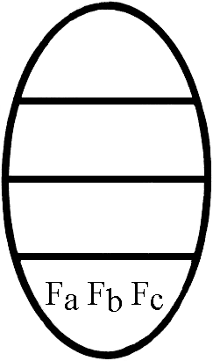
F_{a} F_{b} F_{c} — form of ice (floe size) corresponding to S_{a}, S_{b} and S_{c} respectively (see table in Annex I).
NOTES:
(1) Absence of information on any one of these forms of ice should be reported with an “x” at the corresponding position.
(2) When icebergs are present in sufficient numbers to have a concentration figure, this situation can be reported with F_{a} = 9, the appropriate symbol for S_{a} and the corresponding partial concentration C_{a} (see example in Annex II).
(3) In situations when only two stages of development are present, a dash (-) should be added in place of F_{c} to separate these situations from those when F_{p} and F_{s} are being reported.

(b) Second variant
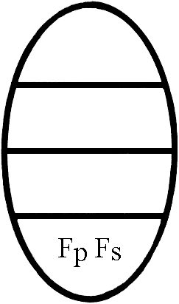
F_{p} F_{s} - Predominant (F_{p}) and secondary (F_{s}) floe size, reported independently from S_{a}, S_{b} and S_{c} (see table in Annex I).
NOTE: If only the predominant floe size (form of ice) is reported, only the symbol for F_{p} shall be reported (see examples in Annex II).

4. SYMBOLS FOR DYNAMIC PROCESSES
- Compacting - Shearing
- Diverging - Drift
Supplementary procedures (optional):
- Compacting:
Slight compacting
Considerable compacting
Strong compacting
- Drift: (in tenths of knots) (e.g. 15 = 1.5 knots)

5. SYMBOLS FOR WATER OPENINGS
- Crack (symbol indicating presence of cracks in the area)
- Crack 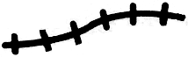 (symbol for a crack at a specific location)
- Lead or
- Frozen lead (the orientation of the crosslines may be varied to distinguish them from other hatching lines)
Supplementary procedures (optional):
- Lead (width) (width of lead in metres or kilometres, e.g. 100-300 m)

6. SYMBOLS FOR TOPOGRAPHICAL FEATURE
- Ridges/hummocks 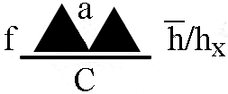
c - concentration (areal coverage) in tenths
f - frequency in number per nautical mile (f is an alternative for C)
$\overline{\text{h}}$ - mean height expressed in decimetres
h_{x} - maximum height expressed in decimetres
a - ridge classification (see table for a in Annexe I).
NOTE: The data for C or f, h and h_{x} are added where known.
- Rafting 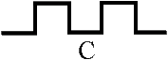
Concentration C as above to be added where known.
- Jammed brash barrier

7. SYMBOL FOR ICE THICKNESS
- Thickness measured 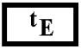 (t_{E} in centimeters)
- Thickness estimated 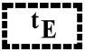 (example: 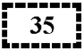 )
When more than one measurement has been taken, both mean and maximum thickness are reported as shown: 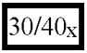

8. SYMBOL FOR STAGE OF MELTING
- Stage of melting 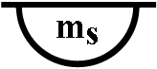 (see table for m_{s} in Annex I)

9. SYMBOL FOR SURFACE FEATURES
- Snow cover: 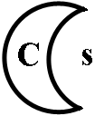
C - concentration (areal coverage) in tenths,
s - snow depth (see table for s in Annex I).
The orientation of the symbol will show the direction of sastrugi, as follows: 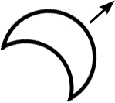

10. SYMBOLS FOR ICE
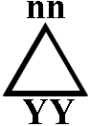
nn — number from WMO Code table 2877 (triangular symbol as given in the columns below)
YY - day of month sighted

10.1 Ice of land origin
- Growler and/or bergy bit
- Iceberg (size unspecified) 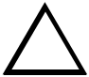 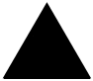
- Iceberg, small 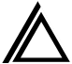
- Iceberg, medium 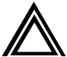
- Iceberg, large 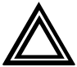 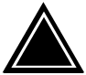
- Iceberg, very large
- Tabular berg indicated by adding a horizontal line through any of the above, e.g. 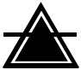
- Ice island
- Radar target (suspected berg)
NOTE: The far right-hand column of symbols may be used when many bergs are present but actual numbers are not known.

10.2 Specification of icebergs (as established by the International Ice Patrol Service)
Size | Height (m) | Length (m)
Growler & bergy bit | up to 5 | less than 15
Iceberg, small | 6-15 | 16-60
Iceberg, medium | 16-45 | 61-122
Iceberg, large | 46-75 | 123-213
Iceberg, very large | over 75 | more than 213
NOTE: Sizes refer to the above-water portion only. If the height and length of a berg fall into different size classifications, use the larger size. Dimensions (in kilometres) of a tabular berg or ice island may be indicated beneath the symbol.

10.3 Ice of sea origin
- Floeberg 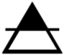

11. SYMBOLS FOR LIMITS
- Undercast
- Limit of visual observations
- Limit of radar observations
- Ice edge by radar
- Observed edge or boundary (Visual or satellite)
- Estimated edge or boundary

12. SYMBOL FOR STRIPS AND PATCHES
- Strips and patches 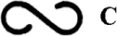
C - concentration in tenths of ice within the area of strips and patches (optional addition).
The symbol is placed within the main ‘oval’ symbol in the section reserved for ‘Form of ice’ (see Example 6 in Annex II).

13. SUPPLEMENTARY PROCEDURES FOR INDICATING TOTAL CONCENTRATION
In order to facilitate readability of the chart, ice-covered areas may be hatched according to total ice concentration. Hatching may be applied to all areas of ice concentration or only to some of them. Whenever hatching is applied, the hatching symbols as shown below shall be used. No international rules are given for the spacing or thickness of the hatching lines: the thickness may be the same throughout all hatched areas, or may vary in the sense that the thickest lines are used for areas of thicker ice.

14. SYMBOLS FOR THE HATCHING OF TOTAL CONCENTRATION OF SEA ICE
- Fast ice or with national variation of hatching to show stage of development (see Note (1) below).
Concentration | Definition | Symbol
10/10 | Consolidated pack ice compact
9-10/10 | Very close pack ice
7-9/10 | Close pack ice
4-6/10 | Open pack ice | (Line spacing is twice that of close pack ice)
1-3/10 | Very open pack ice
<1/10 | Open water
0 | Ice free
 | Bergy water
 | Presence of new ice  (see Note (2) below) | 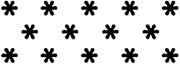 (symbol may be scattered)
NOTES:
(1) The symbol for fast ice may also be used on individual giant floes in cases where there are no risks of the floes being interpreted as fast ice.
(2) When scattered stars are used to indicate the presence of new ice, reporting the actual amount of this stage of development as a component of the total concentration is optional.

15. ADDITIONAL SYMBOLS FOR REGIONAL USE
Symbol adopted for use in the Baltic Sea area:
- Level ice (Line spacing is twice that of close pack ice)

ANNEX I

TABLES OF ICE SYMBOLS

Total concentration of ice (C)

Concentration | Symbol
Ice free
Less than one tenth | 0
1/10 | 1
2/10 | 2
3/10 | 3
4/10 | 4
5/10 | 5
6/10 | 6
7/10 | 7
8/10 | 8
9/10 | 9
More than 9/10 less than 10/10 | 9 +
10/10 | 10
Undetermined or unknown | X

Stage of development and thickness
(S_{o} S_{a} S_{b} S_{c} S_{d})
Numerical classification in Volume I | Element | Thickness | Symbol | Alternative  symbol
 | No stage of development | - | 0
2.1 | New ice | - | 1
2.2 | Nilas; ice rind | <10 cm | 2 | 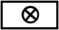
2.4 | Young ice | 10-30 cm | 3
2.4.1 | Gray ice | 10-15 cm | 4
2.4.2 | Gray-white ice | 15-30 cm | 5
2.5 | First-year ice | 30-200 cm | 6
2.5.1 | Thin first-year ice | 30-70 cm | 7
2.5.1a | Thin first-year ice, first stage | 30-50 cm | 8
2.5.1b | Thin first-year ice, second stage | 50-70 cm | 9
2.5.2 | Medium first-year ice | 70-120 cm | 1•
2.5.3 | Thick first-year ice | >120 cm | 4•
2.6 | Old ice |  | 7•
2.6.1 | Second-year ice |  | 8•
2.6.2 | Multi-year ice |  | 9•
10.4 | Ice of land origin |  | 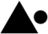 | 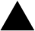
 | Undetermined of unknown |  | x

NOTES:
(1) Use of symbols (figures):
On the horizontal line giving S_{o} S_{a} S_{b} S_{c} only one dot (•) is to be placed to indicate the distinction between classes of any ice having a thickness of over 70 cm (symbols 1• to 9•) from classes with a thickness of below 70 cm (symbols 1 to 9).
Examples:
$\left.\begin{aligned}{\text{S}}_{\text{a}}\text{=2.5.2} \\ {\text{S}}_{\text{b}}\text{=2.5.1} \\ {\text{S}}_{\text{c}}\text{=2.4}\end{aligned}\right\}$ Symbol: 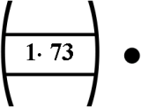 $\left.\begin{aligned}{\text{S}}_{\text{a}}\text{=2.6} \\ {\text{S}}_{\text{b}}\text{=2.5.3} \\ {\text{S}}_{\text{c}}\text{=2.5}\end{aligned}\right\}$ Symbol: 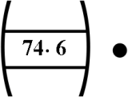 $\left.\begin{aligned}{\text{S}}_{\text{o}}\text{=2.6} \\ {\text{S}}_{\text{a}}\text{=2.5.3} \\ {\text{S}}_{\text{b}}\text{=2.5.1} \\ {\text{S}}_{\text{c}}\text{=2.4}\end{aligned}\right\}$ Symbol: 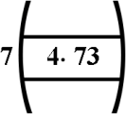
$\left.\begin{aligned}{\text{S}}_{\text{a}}\text{=2.5.1a} \\ {\text{S}}_{\text{b}}\text{=2.4.2} \\ {\text{S}}_{\text{c}}\text{=2.1}\end{aligned}\right\}$ Symbol: 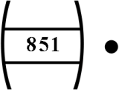 $\left.\begin{aligned}{\text{S}}_{\text{o}}\text{=2.5.2} \\ {\text{S}}_{\text{a}}\text{=2.5.1a} \\ {\text{S}}_{\text{b}}\text{=2.4.2} \\ {\text{S}}_{\text{c}}\text{=}\text{2.1}\end{aligned}\right\}$ Symbol: 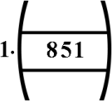
(2) The dot symbol which indicates a distinction between classes of stage of development should be placed midway between the top and the bottom of the figures.

Form of ice
(F_{a} F_{b} F_{c} F_{p} F_{s})
Element | Symbol
Pancake ice | 0
Small ice cake; brash ice | 1
Ice cake | 2
Small floe | 3
Medium floe | 4
Big floe | 5
Vast floe | 6
Giant floe | 7
Fast ice, growlers or floebergs | 8
Icebergs | 9
Undetermined or unknown | x  (for F_{a} F_{b} F_{c} only)

NOTES:
(1) The form of new ice is normally not reported when this stage of development occurs as S_{a} S_{b} or S_{c}. The symbol x - undetermined is used.
(2) Symbol 8 normally indicates fast ice and is used in conjunction with many stages of development S. However, when ice of land origin (symbol ▲ ) is reported, the symbol 8 indicates the presence of growlers or floebergs.

Ridge classification (a)

Element | Symbol
New ridge | 1
Weathered ridge | 2
Very weathered ridge | 3
Aged ridge | 4
Consolidated ridge | 5

Stage of melting (m_{s})

Element | Symbol
No melt | 0
Few puddles | 1
Many puddles | 2
Flooded ice | 3
Few thawholes | 4
Many thawholes | 5
Dried ice | 6
Rotten ice | 7
Few frozen puddles | 8
All puddles frozen | 9

Snow depth (s)

Element | Symbol
No snow | 0
Up to 5 cm | 1
Up to 10 cm | 2
Up to 20 cm | 3
Up to 30 cm | 4
Up to 50 cm | 5
Up to 75 cm | 6
Up to 100 cm | 7
More than 100 cm | 8
Unknown | 9

ANNEX II

EXAMPLES OF THE USE OF THE ‘OVAL’ SYMBOL

Example 1 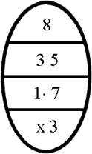 8 tenths of ice; 3 tenths of medium and 5 tenths of thin first-year ice; floe size of medium first-year ice is not known; the floe size of thin first-year ice is small floe.

Example 2 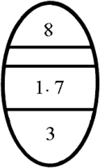 8 tenths of ice; medium and thin first-year ice of which the partial concentrations are not given; predominant floe size is small floe.
Example 3 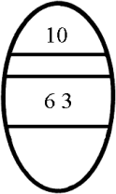 10 tenths of ice; first-year and young ice of which the partial concentrations are not given; no information on form of ice (this example applies particularly to satellite data).
Example 4 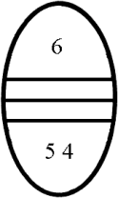 6 tenths of ice in big and medium floes; stages of development not given and therefore there are no partial concentrations.
Example 5 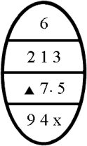 6 tenths of ice; 2 tenths concentration of icebergs, one tenth of old ice and 3 tenths of gray-white ice; the floe size of old ice is medium floe.

Example 6 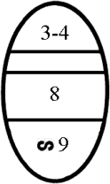 3 to 4 tenths of ice; all thin first-year ice of 30-50 cm thickness; in strips and patches where the concentration is 9 tenths. (With one stage of development, indication of partial concentration is not needed).
Example 7 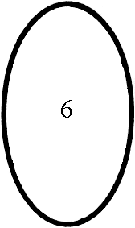 6 tenths of ice; no other details given.
Example 8 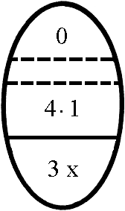 Less than one tenth of ice. Some thick first-year ice in small floes is present and also some new ice but the total concentration is less than one tenth.
Example 9 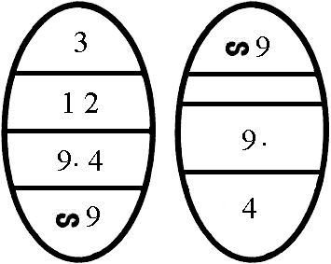 Total concentration is 3/10; 1/10 is multi-year ice; 2/10 - grey ice. The ice is partly distributed in strips and patches within which the concentration is 9/10 of multi-year ice in medium floes.
Example 10 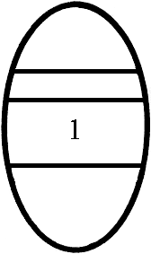 New ice, no concentration or floe size indicated.

In general, throughout the symbology solid lines are used for observed data and dashed lines for estimates. For indicating estimates in the ‘oval’, see the following examples.

Known data | Estimated data | Missing data | Symbol
Concentration, partial concentrations and stage of development |  | Floe size
Concentration | Partial concentrations and stage of development | Floe size
Concentration, stage development and floe size | Partial concentrations
Concentration and partial concentration | Stage of development | Floe size
 | All data

